4. OSI Transport Layer
introduction

Data networks and the Internet support the human network by supplying seamless, reliable communication between people - both locally and around the globe. On a single device, people can use multiple services such as e-mail, the web, and instant messaging to send messages or retrieve information. Applications such as e-mail clients, web browsers, and instant messaging clients allow people to use computers and networks to send messages and find information.
Data from each of these applications is packaged, transported, and delivered to the appropriate server daemon or application on the destination device. The processes described in
the OSI Transport layer accept data from the Application layer and prepare it for addressing at

the Network layer. The Transport layer is responsible for the overall end-to-end transfer of application data.
In this chapter, we examine the role of the Transport layer in encapsulating application data for use by the Network layer. The Transport layer also encompasses these functions:
• Enables multiple applications to communicate over the network at the same time

on a single device.

• Ensures that, if required, all the data is received reliably and in order by the correct application.
• Employs error handling mechanisms.

Learning Objectives

Upon completion of this chapter, you will be able to:

▪ Explain the need for the Transport layer.

▪ Identify the role of the Transport layer as it provides the end-to-end transfer of data between applications.
▪ Describe the role of two TCP/IP Transport layer protocols: TCP and UDP.

▪ Explain the key functions of the Transport layer, including reliability, port addressing, and segmentation.

▪ Explain how TCP and UDP each handle key functions.

▪ Identify when it is appropriate to use TCP or UDP and provide examples of applications that use each protocol.
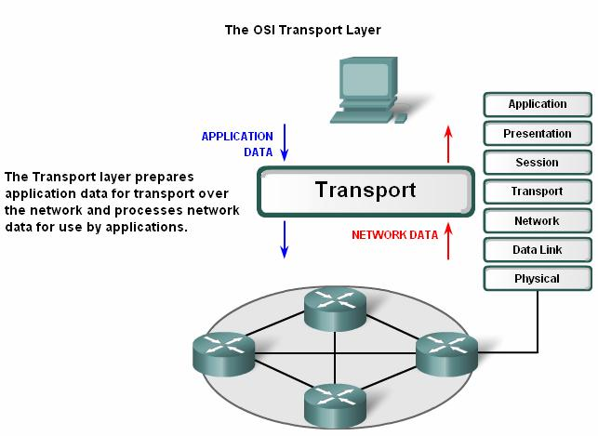

4.1 Roles of the Transport Layer
4.1.1 Purpose of the Transport Layer

The Transport layer provides for the segmentation of data and the control necessary to reassemble these pieces into the various communication streams. Its primary responsibilities to accomplish this are:
- Tracking the individual communication between applications on the source and destination hosts.
- Segmenting data and managing each piece.
- Reassembling the segments into streams of application data.
- Identifying the different applications.
- Data Requirements Vary.
- Separating Multiple Communications.

Tracking Individual Conversation
Any host may have multiple applications that are communicating across the network. Each of these applications will be communicating with one or more applications on remote hosts. It is the responsibility of the Transport layer to maintain the multiple communication streams between these applications.
Segmenting Data
As each application creates a stream data to be sent to a remote application, this data must be prepared to be sent across the media in manageable pieces. The Transport layer protocols describe services that segment this data from the Application layer. This includes the encapsulation required on each piece of data. Each piece of application data requires headers to
be added at the Transport layer to indicate to which communication it is associated.

Reassembling Segments

At the receiving host, each piece of data may be directed to the appropriate application. Additionally, these individual pieces of data must also be reconstructed into a complete data stream that is useful to the Application layer. The protocols at the Transport layer describe the how the Transport layer header information is used to reassemble the data pieces into streams to
be passed to the Application layer.

Identifying the Applications

In order to pass data streams to the proper applications, the Transport layer must identify

the target application. To accomplish this, the Transport layer assigns an application an identifier. The TCP/IP protocols call this identifier a port number. Each software process that needs to access the network is assigned a port number unique in that host. This port number is used in the transport layer header to indicate to which application that piece of data is associated.
The Transport layer is the link between the Application layer and the lower layer that are

responsible for network transmission. This layer accepts data from different conversations and passes it down to the lower layers as manageable pieces that can be eventually multiplexed over
the media.

Applications do not need to know the operational details of the network in use. The

applications generate data that is sent from one application to another, without regard to the destination host type, the type of media over which the data must travel, the path taken by the data, the congestion on a link, or the size of the network.
Additionally, the lower layers are not aware that there are multiple applications sending data on the network. Their responsibility is to deliver data to the appropriate device. The Transport layer then sorts these pieces before delivering them to the appropriate application.
Data Requirements Vary

Because different applications have different requirements, there are multiple Transport layer protocols. For some applications, segments must arrive in a very specific sequence in order to be processed successfully. In some cases, all of the data must be received for any of it
to be of use. In other cases, an application can tolerate some loss of data during transmission

over the network.

In today's converged networks, applications with very different transport needs may be communicating on the same network. The different Transport layer protocols have different rules allowing devices to handle these diverse data requirements.
Some protocols provide just the basic functions for efficiently delivering the data pieces

between the appropriate applications. These types of protocols are useful for applications whose data is sensitive to delays.
Other Transport layer protocols describe processes that provide additional features, such

as ensuring reliable delivery between the applications. While these additional functions provide more robust communication at the Transport layer between applications, they have additional overhead and make larger demands on the network.

Separating Multiple Communications

Consider a computer connected to a network that is simultaneously receiving and sending

e-mail and instant messages, viewing websites, and conducting a VoIP phone call. Each of these applications is sending and receiving data over the network at the same time. However, data from the phone call is not directed to the web browser, and text from an instant message does not appear in an e-mail.
Further, users require that an e-mail or web page be completely received and presented

for the information to be considered useful. Slight delays are considered acceptable to ensure that the complete information is received and presented.
In contrast, occasionally missing small parts of a telephone conversation might be considered acceptable. One can either infer the missing audio from the context of the conversation or ask the other person to repeat what they said. This is considered preferable to
the delays that would result from asking the network to manage and resend missing segments.

In this example, the user - not the network - manages the resending or replacement of missing

information.

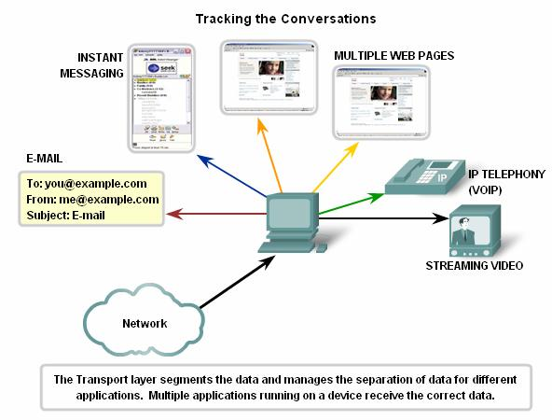

As explained in a previous chapter, sending some types of data - a video for example - across a network as one complete communication stream could prevent other communications from occurring at the same time. It also makes error recovery and retransmission of damaged data difficult.
Dividing data into small parts, and sending these parts from the source to the destination, enables many different communications to be interleaved (multiplexed) on the same network.
Segmentation of the data, in accordance with Transport layer protocols, provides the means to both send and receive data when running multiple applications concurrently on a computer. Without segmentation, only one application, the streaming video for example, would
be able to receive data. You could not receive e-mails, chat on instant messenger, or view web pages while also viewing the video.

At the Transport layer, each particular set of pieces flowing between a source application

and a destination application is known as a conversation.

To identify each segment of data, the Transport layer adds to the piece a header containing binary data. This header contains fields of bits. It is the values in these fields that enable different Transport layer protocols to perform different functions.
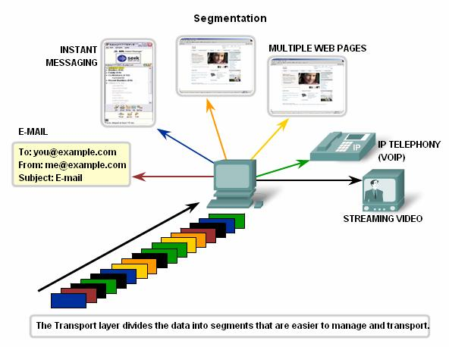

4.1 Roles of the Transport Layer
4.1.2 Controlling the Conversations

The primary functions specified by all Transport layer protocols include:

Segmentation and Reassembly - Most networks have a limitation on the amount of data that can be included in a single PDU. The Transport layer divides application data into blocks
of data that are an appropriate size. At the destination, the Transport layer reassembles the data before sending it to the destination application or service.

Conversation Multiplexing - There may be many applications or services running on each host in the network. Each of these applications or services is assigned an address known as
a port so that the Transport layer can determine with which application or service the data is

identified.

In addition to using the information contained in the headers, for the basic functions of data segmentation and reassembly, some protocols at the Transport layer provide:
• Connection-oriented conversations

• Reliable delivery

• Ordered data reconstruction

• Flow control
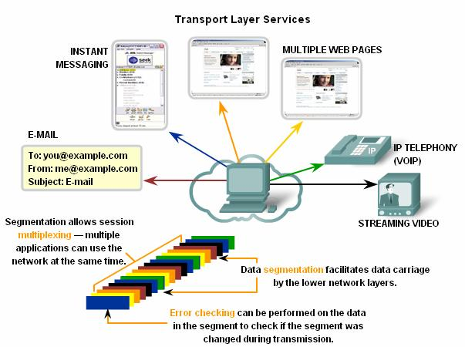

Establishing a Session
The Transport layer can provide this connection orientation by creating a sessions between the applications. These connections prepare the applications to communicate with each other before any data is transmitted. Within these sessions, the data for a communication between the two applications can be closely managed.

Reliable Delivery
For many reasons, it is possible for a piece of data to become corrupted, or lost

completely, as it is transmitted over the network. The Transport layer can ensure that all pieces reach their destination by having the source device to retransmit any data that is lost.
Same Order Delivery
Because networks may provide multiple routes that can have different transmission times, data can arrive in the wrong order. By numbering and sequencing the segments, the Transport layer can ensure that these segments are reassembled into the proper order.
Flow Control
Network hosts have limited resources, such as memory or bandwidth. When Transport layer is aware that these resources are overtaxed, some protocols can request that the sending application reduce the rate of data flow. This is done at the Transport layer by regulating the amount of data the source transmits as a group. Flow control can prevent the loss of segments
on the network and avoid the need for retransmission.

As the protocols are discussed in this chapter, these services will be explained in more

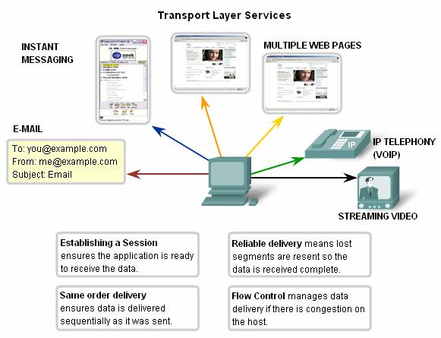
detail.

4.1 Roles of the Transport Layer
4.1.3 Supporting Reliable Communication

Recall that the primary function of the Transport layer is to manage the application data

for the conversations between hosts. However, different applications have different requirements for their data, and therefore different Transport protocols have been developed to meet these requirements.
A Transport layer protocol can implement is a method to ensure reliable delivery of the data. In networking terms, reliability means ensuring that each piece of data that the source sends arrives at the destination. At the Transport layer the three basic operations of reliability are:
• tracking transmitted data

• acknowledging received data

• retransmitting any unacknowledged data

This requires the processes of Transport layer of the source to keep track of all the data pieces of each conversation and the retransmit any of data that did were not acknowledged by
the destination. The Transport layer of the receiving host must also track the data as it is received and acknowledge the receipt of the data.
These reliability processes place additional overhead on the network resources due to the acknowledgement, tracking, and retransmission. To support these reliability operations, more control data is exchanged between the sending and receiving hosts. This control information is contained in the Layer 4 header.
This creates a trade-off between the value of reliability and the burden it places on the

network. Application developers must choose which transport protocol type is appropriate based on the requirements of their applications. At the Transport layer, there are protocols that specify methods for either reliable, guaranteed delivery or best-effort delivery. In the context of networking, best-effort delivery is referred to as unreliable, because there is no acknowledgement that the data is received at the destination.

Determining the Need for Reliability

Applications, such as databases, web pages, and e-mail, require that all of the sent data arrive at the destination in its original condition, in order for the data to be useful. Any missing data could cause a corrupt communication that is either incomplete or unreadable. Therefore, these applications are designed to use a Transport layer protocol that implements reliability. The additional network overhead is considered to be required for these applications.
Other applications are more tolerant of the loss of small amounts of data. For example, if

one or two segments of a video stream fail to arrive, it would only create a momentary disruption in the stream. This may appear as distortion in the image but may not even be noticeable to the user.
Imposing overhead to ensure reliability for this application could reduce the usefulness of

the application. The image in a streaming video would be greatly degraded if the destination device had to account for a lost data and delay the stream while waiting for its arrival. It is better to render the best image possible at the time with the segments that arrive and forego reliability. If reliability is required for some reason, these applications can provide error checking and retransmission requests.
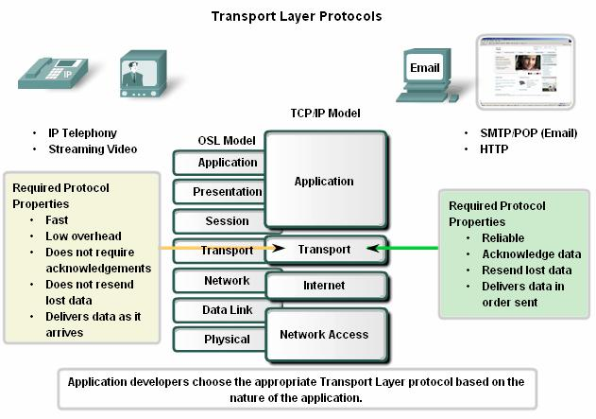

4.1 Roles of the Transport Layer
4.1.4 TCP and UDP

The two most common Transport layer protocols of TCP/IP protocol suite are Transmission Control Protocol (TCP) and User Datagram Protocol (UDP). Both protocols manage the communication of multiple applications. The differences between the two are the specific functions that each protocol implements.
User Datagram Protocol (UDP)

UDP is a simple, connectionless protocol, described in RFC 768. It has the advantage of providing for low overhead data delivery. The pieces of communication in UDP are called datagrams. These datagrams are sent as "best effort" by this Transport layer protocol.
▪ Applications that use UDP include:

▪ Domain Name System (DNS).

▪ Video Streaming.

▪ Voice over IP (VoIP).

Transmission Control Protocol (TCP)

TCP is a connection-oriented protocol, described in RFC 793. TCP incurs additional overhead to gain functions. Additional functions specified by TCP are the same order delivery, reliable delivery, and flow control. Each TCP segment has 20 bytes of overhead in the header encapsulating the Application layer data, whereas each UDP segment only has 8 bytes of overhead. See the figure for a comparison.
Applications that use TCP are:

• Web Browsers.

• E-mail.

• File Transfers.

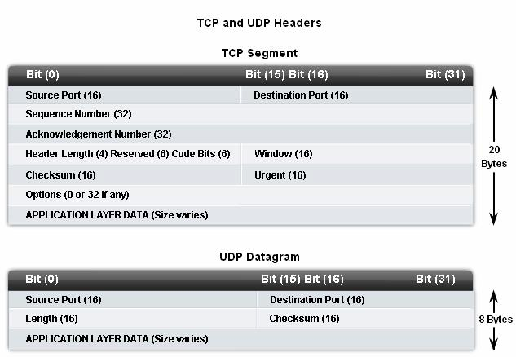

4.1 Roles of the Transport Layer
4.1.5 Port Addressing

Identifying the Conversations

Consider the earlier example of a computer simultaneously receiving and sending e-mail, instant messages, web pages, and a VoIP phone call.
The TCP and UDP based services keep track of the various applications that are

communicating. To differentiate the segments and datagrams for each application, both TCP

and UDP have header fields that can uniquely identify these applications. These unique identifiers are the port numbers,
In the header of each segment or datagram, there is a source and destination port. The source port number is the number for this communication associated with the originating application on the local host. The destination port number is the number for this communication associated with the destination application on the remote host.

Port numbers are assigned in various ways, depending on whether the message is a

request or a response. While server processes have static port numbers assigned to them, clients dynamically choose a port number for each conversation.
When a client application sends a request to a server application, the destination port

contained in the header is the port number that is assigned to the service daemon running on the remote host. The client software must know what port number is associated with the server process on the remote host. This destination port number is configured, either by default or manually. For example, when a web browser application makes a request to a web server, the browser uses TCP and port number 80 unless otherwise specified. This is because TCP port 80
is the default port assigned to web-serving applications. Many common applications have default port assignments.
The source port in a segment or datagram header of a client request is randomly

generated. As long as it does not conflict with other ports in use on the system, the client can choose any port number. This port number acts like a return address for the requesting application. The Transport layer keeps track of this port and the application that initiated the request so that when a response is returned, it can be forwarded to the correct application. The requesting application port number is used as the destination port number in the response coming back from the server.
The combination of the Transport layer port number and the Network layer IP address assigned to the host uniquely identifies a particular process running on a specific host device. This combination is called a socket. Occasionally, you may find the terms port number and socket used interchangeably. In the context of this course, the term socket refers only to the unique combination of IP address and port number. A socket pair, consisting of the source and destination IP addresses and port numbers, is also unique and identifies the conversation between the two hosts.
For example, an HTTP web page request being sent to a web server (port 80) running on

a host with a Layer 3 IPv4 address of 192.168.1.20 would be destined to socket
192.168.1.20:80.

If the web browser requesting the web page is running on host 192.168.100.48 and the

Dynamic port number assigned to the web browser is 49152, the socket for the web page would

be 192.168.100.48:49152.
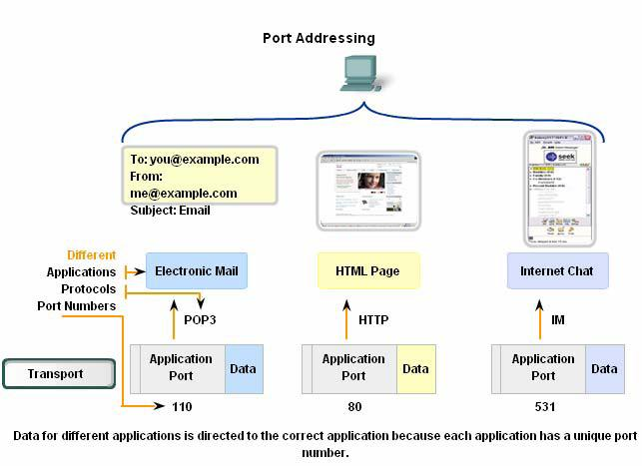

The Internet Assigned Numbers Authority (IANA) assigns port numbers. IANA is a standards body that is responsible for assigning various addressing standards.
There are different types of port numbers:

Well Known Ports (Numbers 0 to 1023) - These numbers are reserved for services and applications. They are commonly used for applications such as HTTP (web server) POP3/SMTP (e-mail server) and Telnet. By defining these well-known ports for server applications, client applications can be programmed to request a connection to that specific port
and its associated service.

Registered Ports (Numbers 1024 to 49151) - These port numbers are assigned to user processes or applications. These processes are primarily individual applications that a user has chosen to install rather than common applications that would receive a Well Known Port. When
not used for a server resource, these ports may also be used dynamically selected by a client as
its source port.

Dynamic or Private Ports (Numbers 49152 to 65535) - Also known as Ephemeral Ports,

these are usually assigned dynamically to client applications when initiating a connection. It is

not very common for a client to connect to a service using a Dynamic or Private Port (although some peer-to-peer file sharing programs do).

Using both TCP and UDP

Some applications may use both TCP and UDP. For example, the low overhead of UDP enables DNS to serve many client requests very quickly. Sometimes, however, sending the requested information may require the reliability of TCP. In this case, the well known port number of 53 is used by both protocols with this service.
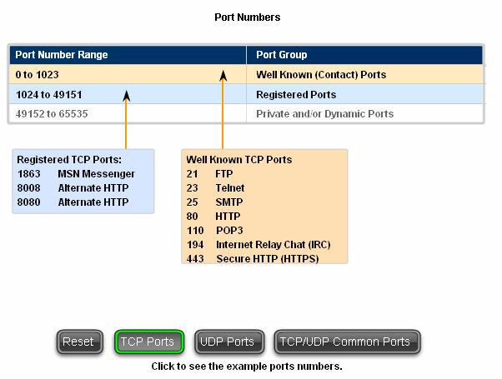

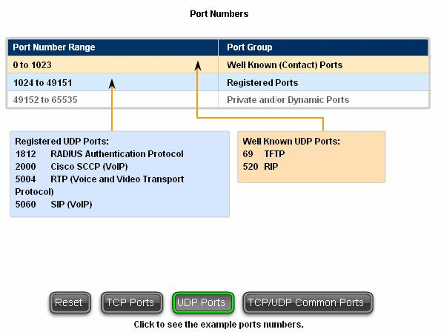

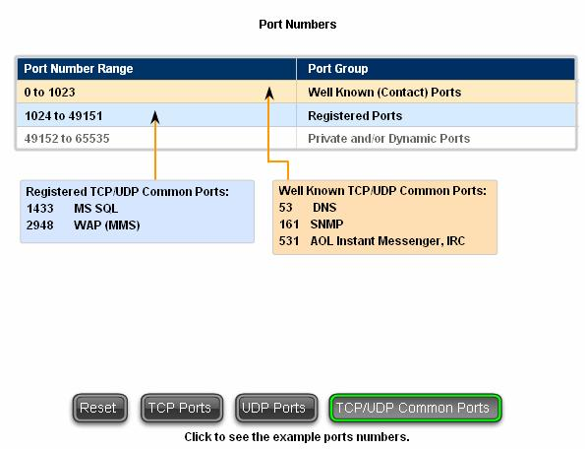

Sometimes it is necessary to know which active TCP connections are open and running

on a networked host. Netstat is an important network utility that can be used to verify those connections. Netstat lists the protocol in use, the local address and port number, the foreign address and port number, and the state of the connection.
Unexplained TCP connections can pose a major security threat. This is because they can indicate that something or someone is connected to the local host. Additionally, unnecessary TCP connections can consume valuable system resources thus slowing down the host's performance. Netstat should be used to examine the open connections on a host when performance appears to be compromised.
Many useful options are available for the netstat command.

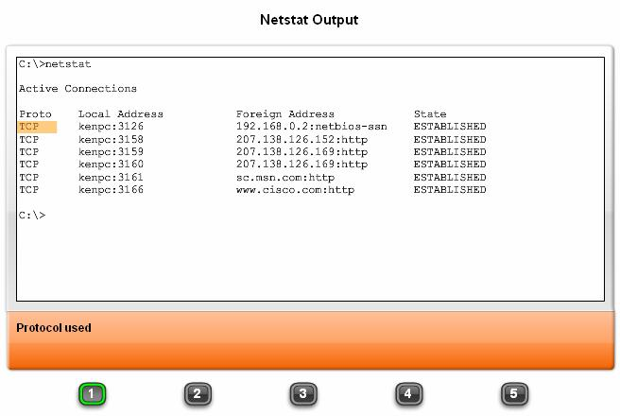

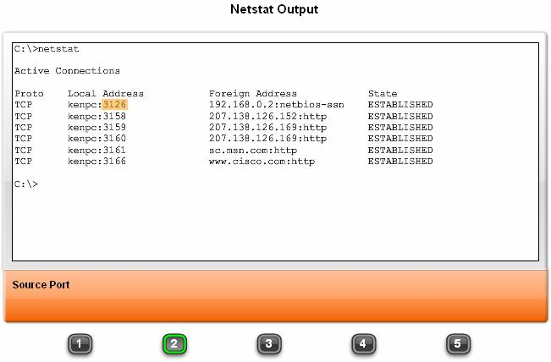

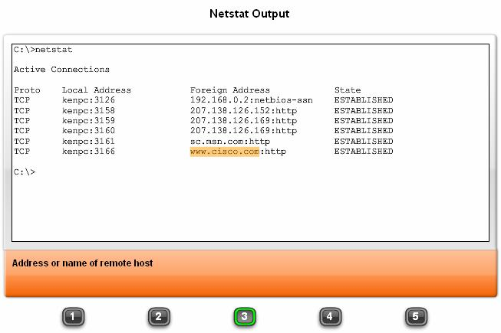

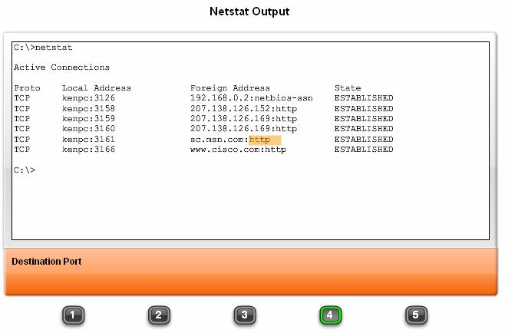

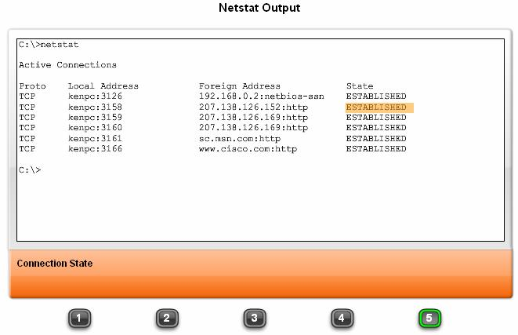

4.1 Roles of the Transport Layer
4.1.6 Segmentation and Reassembly – Divide and Conquer

A previous chapter explained how PDUs are built by passing data from an application down through the various protocols to create a PDU that is then transmitted on the medium. At
the destination host, this process is reversed until the data can be passed up to the application.

Some applications transmit large amounts of data - in some cases, many gigabytes. It would be impractical to send all of this data in one large piece. No other network traffic could
be transmitted while this data was being sent. A large piece of data could take minutes or even

hours to send. In addition, if there were any error, the entire data file would have to be lost or resent. Network devices would not have memory buffers large enough to store this much data while it is transmitted or received. The limit varies depending on the networking technology
and specific physical medium being in use.

Dividing application data into pieces both ensures that data is transmitted within

the limits of the media and that data from different applications can be multiplexed on to the media.
TCP and UDP Handle Segmentation Differently

In TCP, each segment header contains a sequence number. This sequence number allows

the Transport layer functions on the destination host to reassemble segments in the order in which they were transmitted. This ensures that the destination application has the data in the exact form the sender intended.
Although services using UDP also track the conversations between applications, they are

not concerned with the order in which the information was transmitted, or in maintaining a connection. There is no sequence number in the UDP header. UDP is a simpler design and generates less overhead than TCP, resulting in a faster transfer of data.
Information may arrive in a different order than it was transmitted because different packets may take different paths through the network. An application that uses UDP must tolerate the fact that data may not arrive in the order in which it was sent.
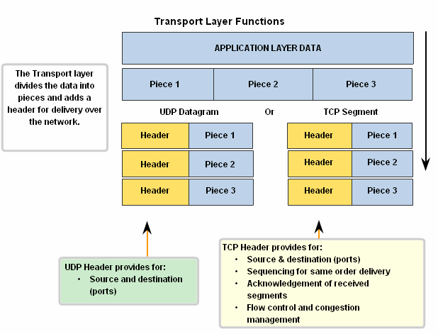

The key distinction between TCP and UDP is reliability
The reliability of TCP communication is performed using connection-oriented sessions. Before a host using TCP sends data to another host, the Transport layer initiates a process to create a connection with the destination. This connection enables the tracking of a session, or communication stream between the hosts. This process ensures that each host is aware of and prepared for the communication. A complete TCP conversation requires the establishment of a session between the hosts in both directions.

After a session has been established, the destination sends acknowledgements to the source for the segments that it receives. These acknowledgements form the basis of reliability within the TCP session. As the source receives an acknowledgement, it knows that the data has been successfully delivered and can quit tracking that data. If the source does not receive an acknowledgement within a predetermined amount of time, it retransmits that data to the destination.
Part of the additional overhead of using TCP is the network traffic generated by

acknowledgements and retransmissions. The establishment of the sessions creates overhead in

the form of additional segments being exchanged. There is also additional overhead on the

individual hosts created by the necessity to keep track of which segments are awaiting

acknowledgement and by the retransmission process.

This reliability is achieved by having fields in the TCP segment, each with a specific function, as shown in the figure. These fields will be discussed later in this section.
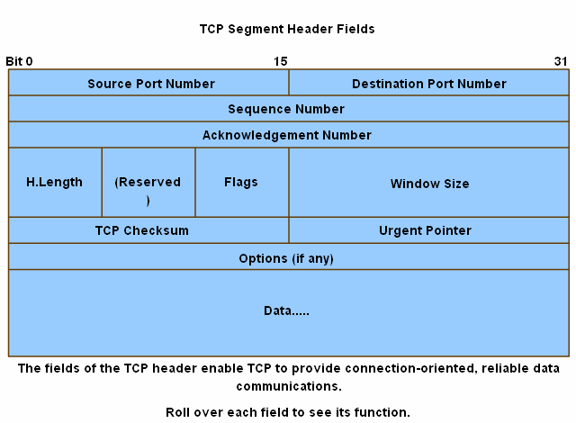
4.2 The TCP protocol- Communicating with Reliability
4.2.2 TCP Server Processes

As discussed in the previous chapter, application processes run on servers. These processes wait until a client initiates communication with a request for information or other services.
Each application process running on the server is configured to use a port number, either

by default or manually by a system administrator. An individual server cannot have two services assigned to the same port number within the same Transport layer services. A host running a web server application and a file transfer application cannot have both configured to use the same port (for example, TCP port 8080). When an active server application is assigned to a specific port, that port is considered to be "open" on the server. This

means that the Transport layer accepts and processes segments addressed to that port. Any

incoming client request addressed to the correct socket is accepted and the data is passed to the server application. There can be many simultaneous ports open on a server, one for each active server application. It is common for a server to provide more than one service, such as a web server and an FTP server, at the same time.
One way to improve security on a server is to restrict server access to only those ports associated with the services and applications that should be accessible to authorized requestors. The figure shows the typical allocation of source and destination ports in TCP
client/server operations.

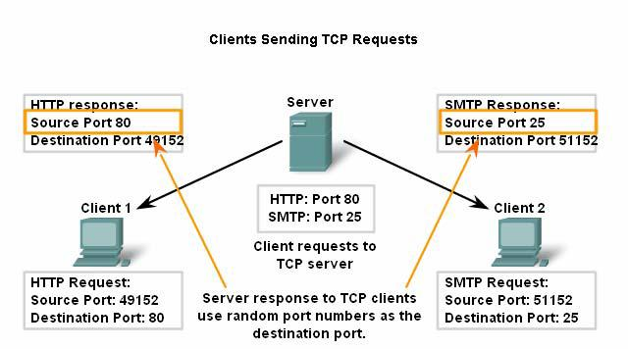

4.2 The TCP protocol- Communicating with Reliability
4.2.3 TCP Connection Establishment and Termination

When two hosts communicate using TCP, a connection is established before data can be exchanged. After the communication is completed, the sessions are closed and the connection is terminated. The connection and session mechanisms enable TCP's reliability function.
See the figure for the steps to establish and terminate a TCP connection.

The host tracks each data segment within a session and exchanges information about what data is received by each host using the information in the TCP header.

Each connection represents two one-way communication streams, or sessions. To establish the connection, the hosts perform a three-way handshake. Control bits in the TCP
header indicate the progress and status of the connection. The three-way handshake:

- Establishes that the destination device is present on the network.

- Verifies that the destination device has an active service and is accepting requests

on the destination port number that the initiating client intends to use for the session.

- Informs the destination device that the source client intends to establish a communication session on that port number.
In TCP connections, the host serving as a client initiates the session to the server. The three steps in TCP connection establishment are:
1. The initiating client sends a segment containing an initial sequence value, which serves

as a request to the server to begin a communications session.

2. The server responds with a segment containing an acknowledgement value equal to the received sequence value plus 1, plus its own synchronizing sequence value. The value is one greater than the sequence number because there is no data contained to be acknowledged. This acknowledgement value enables the client to tie the response back to the original segment that it sent to the server.
3. Initiating client responds with an acknowledgement value equal to the sequence value

it received plus one. This completes the process of establishing the connection.

To understand the three-way handshake process, it is important to look at the various values that the two hosts exchange. Within the TCP segment header, there are six 1-bit fields that contain control information used to manage the TCP processes. Those fields are:
• URG - Urgent pointer field significant.

• ACK - Acknowledgement field significant.

• PSH - Push function.

• RST - Reset the connection.

• SYN - Synchronize sequence numbers.
• FIN- No more data from sender.

These fields are referred to as flags, because the value of one of these fields is only 1 bit and, therefore, has only two values: 1 or 0. When a bit value is set to 1, it indicates what control information is contained in the segment.
Using a four-step process, flags are exchanged to terminate a TCP connection.
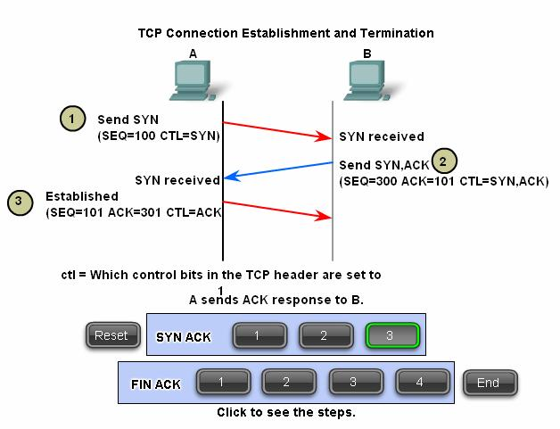

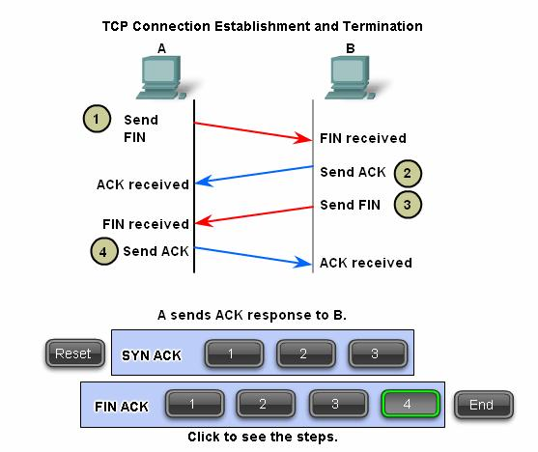

4.2 The TCP protocol- Communicating with Reliability
4.2.4 TCP Three- Way Handshake

Using the Wireshark outputs, you can examine the operation of the TCP 3-way handshake:
Step 1

A TCP client begins the three-way handshake by sending a segment with the SYN

(Synchronize Sequence Number) control flag set, indicating an initial value in the sequence number field in the header. This initial value for the sequence number, known as the Initial Sequence Number (ISN), is randomly chosen and is used to begin tracking the flow of data from the client to the server for this session. The ISN in the header of each segment is increased
by one for each byte of data sent from the client to the server as the data conversation continues.

As shown in the figure, output from a protocol analyzer shows the SYN control flag and the relative sequence number.
The SYN control flag is set and the relative sequence number is at 0. Although the protocol analyzer in the graphic indicates the relative values for the sequence and acknowledgement numbers, the true values are 32 bit binary numbers. We can determine the actual numbers sent in the segment headers by examining the Packet Bytes pane. Here you can
see the four bytes represented in hexadecimal.

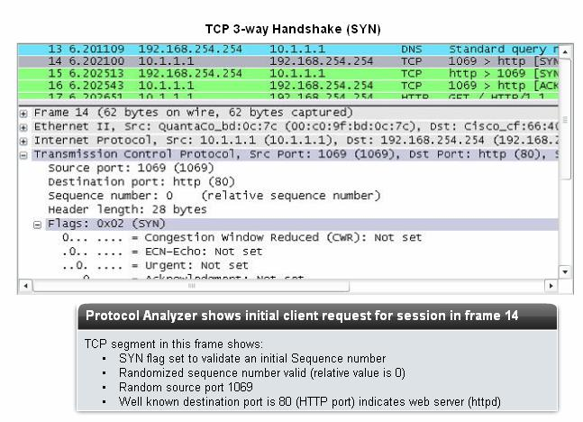

Step 2

The TCP server needs to acknowledge the receipt of the SYN segment from the client to establish the session from the client to the server. To do so, the server sends a segment back to
the client with the ACK flag set indicating that the Acknowledgment number is significant. With this flag set in the segment, the client recognizes this as an acknowledgement that the server received the SYN from the TCP client.
The value of the acknowledgment number field is equal to the client initial sequence

number plus 1. This establishes a session from the client to the server. The ACK flag will remain set for the balance of the session. Recall that the conversation between the client and the server is actually two one-way sessions: one from the client to the server, and the other from the server to the client. In this second step of the three-way handshake, the server must initiate the response from the server to the client. To start this session, the server uses the SYN flag in the same way that the client did. It sets the SYN control flag in the header to establish a session from the server to the client. The SYN flag indicates that the initial value of the sequence

number field is in the header. This value will be used to track the flow of data in this session

from the server back to the client.

As shown in the figure, the protocol analyzer output shows that the ACK and SYN

control flags are set and the relative sequence and acknowledgement numbers are shown.
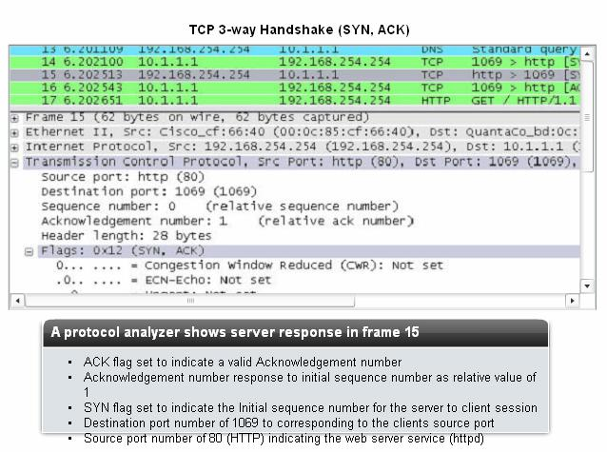
Step 3

Finally, the TCP client responds with a segment containing an ACK that is the response

to the TCP SYN sent by the server. There is no user data in this segment. The value in the acknowledgment number field contains one more than the initial sequence number received from the server. Once both sessions are established between client and server, all additional segments exchanged in this communication will have the ACK flag set.
As shown in the figure, the protocol analyzer output shows the ACK control flag set and

the relative sequence and acknowledgement numbers are shown.

Security can be added to the data network by:
• Denying the establishment of TCP sessions

• Only allowing sessions to be established for specific services

• Only allowing traffic as a part of already established sessions.

This security can be implemented for all TCP sessions or only for selected sessions.

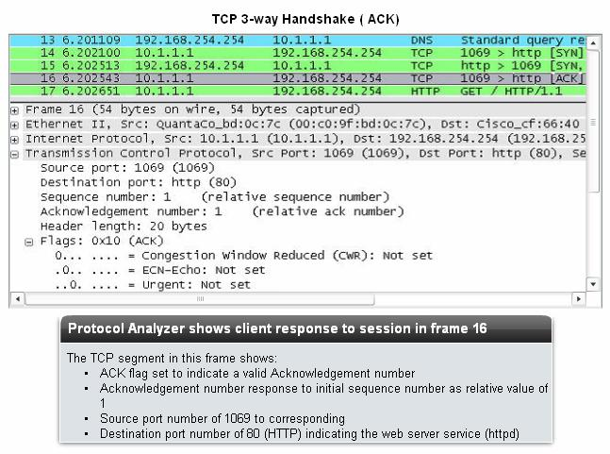

4.2 The TCP protocol- Communicating with Reliability
4.2.5 TCP Session Termination

To close a connection, the FIN (Finish) control flag in the segment header must be set. To

end each one-way TCP session, a two-way handshake is used, consisting of a FIN segment and

an ACK segment. Therefore, to terminate a single conversation supported by TCP, four exchanges are needed to end both sessions.

Note: In this explanation, the terms client and server are used in this description as a reference for simplicity, but the termination process can be initiated by any two hosts that complete the session:
1. When the client has no more data to send in the stream, it sends a segment with the

FIN flag set.
2. The server sends an ACK to acknowledge the receipt of the FIN to terminate the

session from client to server.

3. The server sends a FIN to the client, to terminate the server to client session.

4. The client responds with an ACK to acknowledge the FIN from the server.

When the client end of the session has no more data to transfer, it sets the FIN flag in the header of a segment. Next, the server end of the connection will send a normal segment containing data with the ACK flag set using the acknowledgment number, confirming that all
the bytes of data have been received. When all segments have been acknowledged, the session

is closed.

The session in the other direction is closed using the same process. The receiver indicates that there is no more data to send by setting the FIN flag in the header of a segment sent to the source. A return acknowledgement confirms that all bytes of data have been received and that session is, in turn, closed.
As shown in the figure, the FIN and ACK control flags are set in the segment header, thereby closing a HTTP session.
It is also possible to terminate the connection by a three-way handshake. When the client

has no more data to send, it sends a FIN to the server. If the server also has no more data to send, it can reply with both the FIN and ACK flags set, combining two steps into one. The client replies with an ACK.

4.5 Summary and Review

The Transport layer provides for data network needs by:

• Dividing data received from an application into segments

• Adding a header to identify and manage each segment

• Using the header information to reassemble the segments back into application data

• Passing the assembled data to the correct application

UDP and TCP are common Transport layer protocols.

UDP datagrams and TCP segments have headers prefixed to the data that include a source port number and destination port number. These port numbers enable data to be directed
to the correct application running on the destination computer.

TCP does not pass any data to the network until it knows that the destination is ready to receive it. TCP then manages the flow of the data and resends any data segments that are not acknowledged as being received at the destination. TCP uses mechanisms of handshaking, timers and acknowledgements, and dynamic windowing to achieve these reliable features. This
reliability does, however, impose overhead on the network in terms of much larger segment

headers and more network traffic between the source and destination managing the data transport.
If the application data needs to be delivered across the network quickly, or if network

bandwidth cannot support the overhead of control messages being exchanged between the source and the destination systems, UDP would be the developer's preferred Transport layer protocol. Because UDP does not track or acknowledge the receipt of datagrams at the destination - it just passes received datagrams to the Application layer as they arrive - and does
not resend lost datagrams. However, this does not necessarily mean that the communication

itself is unreliable; there may be mechanisms in the Application layer protocols and services that process lost or delayed datagrams if the application has these requirements.
The choice of Transport layer protocol is made by the developer of the application to best

meet the user requirements. The developer bears in mind, though, that the other layers all play a part in data network communications and will influence its performance.
